L03: Preparation Assignment Answer Key

Name: __________________________

Part I: Concepts Use the information in the reading assignment to complete these questions.

- Match the following statistical terms with their appropriate definitions.
_c__ Shape of the distribution
_a__ Center of the distribution
_b__ Spread of the distribution
a. Average, mean, median, mode
b. Standard deviation, variance
c. Symmetric, bell-shaped, skewed right, and skewed left, uniform, unimodal, bimodal, or multimodal

- Define standard deviation.
The standard deviation is a measure of the spread in a distribution. If the standard deviation is small then the data tend to be closer together. If the standard deviation is large, the data is usually more spread out.
- Before your Group Preparation session, explain “standard deviation” to a roommate, family member, or other person who has not studied statistics. Describe the experience. How did you explain this idea?
Answers will vary.
- Define sample variance.
Sample variance is also a measure of spread in a data set. The sample variance is an estimator of the true population variance. The sample variance is just the sample standard deviation squared or $s^{2}.$

- Provide a definition and/or a brief description of the following terms.
Percentiles – A percentile is a number such that a specified percentage of the data are at or below this number, such as at the 50th percentile, this value is as large or larger than 50% of all the data.
Quartiles – Quartiles are just three special percentiles, 25th, 50th, and 75th percentiles divide the data into fourths.
Five-number summary – The five number summary is comprised of the minimum, first quartile, median, third quartile, and maximum. It is just a good way to summarize the data into just five numbers.
Boxplot – A boxplot is a graphical representation of the five-number summary.
Part II: Application

- The following data set are data on stock performance of specific companies. Find the mean, standard deviation and sample size for each of the companies A-E. Click on the link to access this data set. (MysteryInvestmentOpportunities)
A: Mean = 21.276, Standard Deviation = 37.679, and n = 41
B: Mean = 33.482, Standard Deviation = 49.311, and n = 25
C. Mean = 41.122, Standard Deviation = 79.177, and n = 27
D. Mean = 0.706, Standard Deviation = 21.054, and n = 49
E. Mean = -1.084, Standard Deviation = 21.297 and n = 32

- Make a histogram of the stock performance data for your assigned company. Paste your graph here.
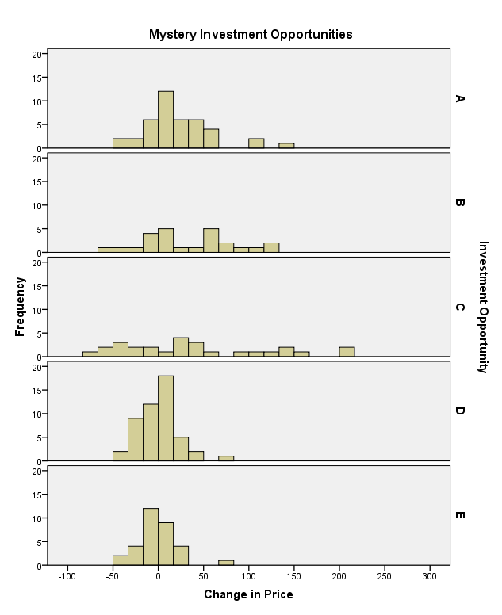
- Compare the results you obtained with the others in your group. Describe the differences and similarities between the different graphs.
Answers will vary but should talk about shape, center, and spread of the different graphs and data sets.
- If you were saving for retirement, which of these five companies would be the most attractive investment? Justify your answer.
Answers may vary, students should choose a company and justify why. They will probably choose B or C, because they have the highest means.

- Create a table to compute the standard deviation “by hand” using the data Severe Bird Flu Data, available on the wiki page, http://byui-fdmat-wiki.pagodabox.com/index.php?title=Describing_Quantitative_Data:_Shape,_Center_%26_Spread )

Column 1 | Column 2 | Column 3
Observation, x | Deviation from the Mean | Squared Deviation from the Mean
39.1 | -0.229 | 0.052
39.5 | 0.171 | 0.029
38.9 | -0.429 | 0.184
39.2 | -0.129 | 0.017
39.9 | 0.571 | 0.326
39.7 | 0.371 | 0.138
39.0 | -0.329 | 0.108
Mean = 39.329 | Sum = 0 | Sum = 0.854
Variance: |  | 0.142
Standard Deviation: |  | 0.377

